**Compiler Project 1**

**Report**

Major : Software

Student ID : 2016024811

Student Name : Kyung Ho, Park

Submission Deadline : 11/1(Sun) 23:59:59

**Contents Overview**

1. Compilation Method and Environment
2. Implementation Description
3. How to Operate & Example and Result Screenshot
4. **Compilation Method and Environment**



On Oracle VM 6.1.4, Ubuntu Linux 18.04 LTS (bionic)

Using given Makefile_example.txt

By adding –lfl option for target lex.yy.o and run below command,

* cp Makefile_example.txt Makefile

/loucomp’s original Makefile is replaced with new one.

Simple “make” command generates executable **scanner_cimpl** and **scanner_flex** at once.

Example of executing **make** command is specified in third content

1. **Implementation Description**

Both for C-implementation and flex-implementation, I edited

* globals.h
* util.c
* main.c

1. in globals.h

changed constant **MAX_RESERVED** from 12 to (6)

According to the project specification, I also changed **enum** named “ **TokenType** ”’s entries, which was implemented to be used as Tiny Compiler Scanner, into C-minus Style.

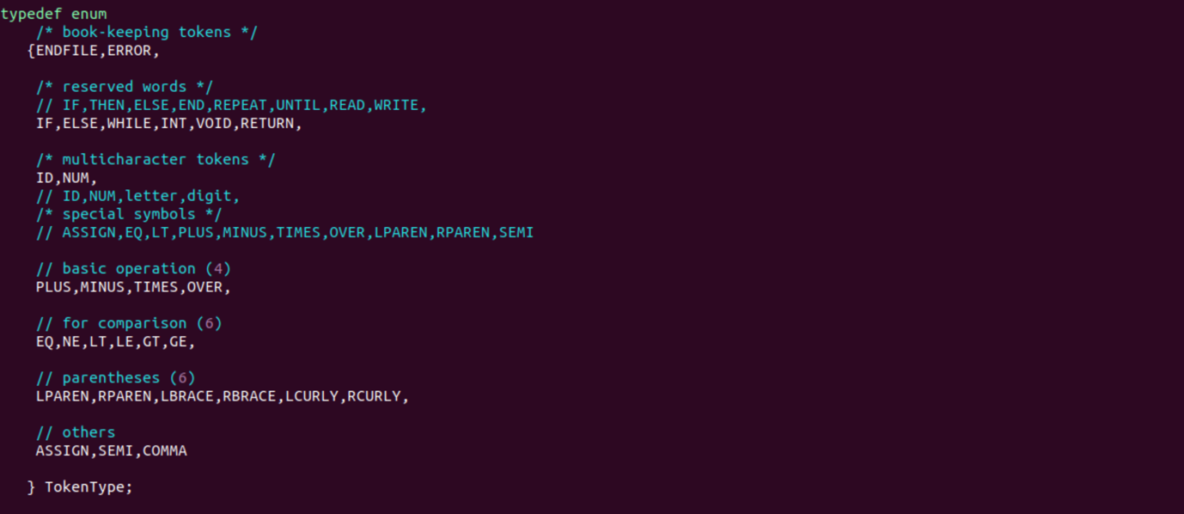

2. In util.c

I edited printToken() function for transforming Tiny-compiler implementation into C-minus style.

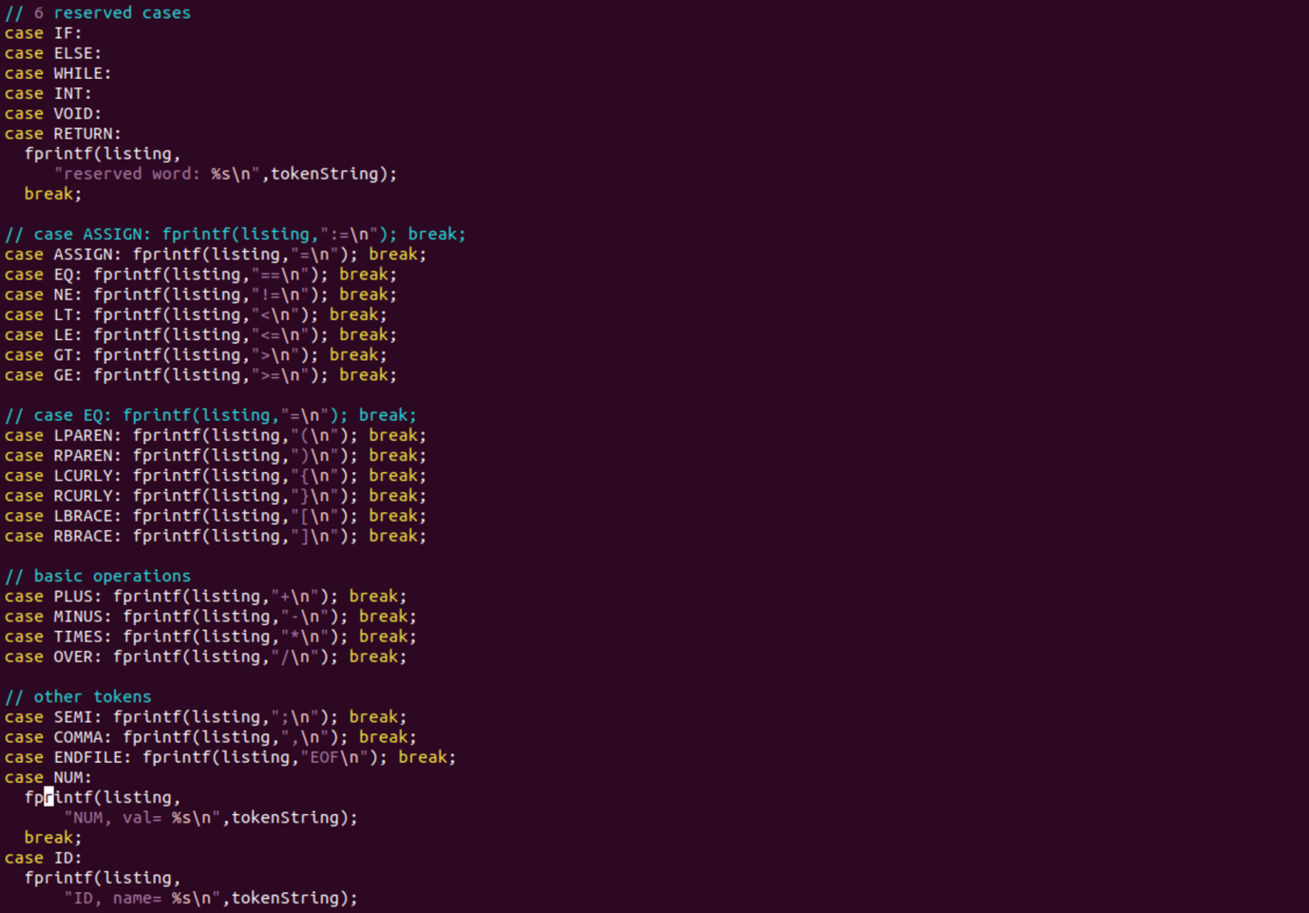

3. main.c

Changed option for **TraceScan** and **EchoSource** to be TRUE.



1. For C – Implementation

Edited **scan.c**

- Adjusted **reservedWords**

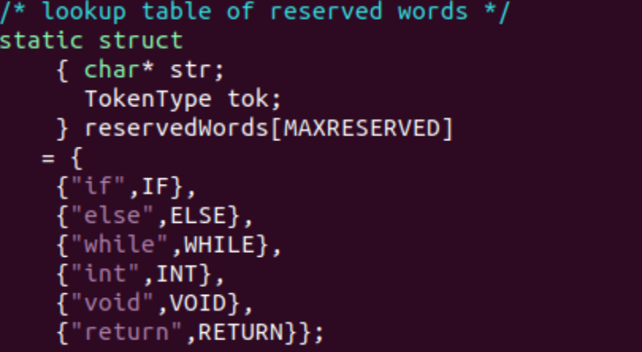

**-** Adjusted **StateType**

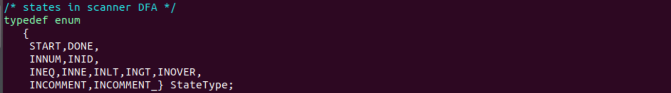

For adjusted states, changed transition logic

ex) Case INLT (newly created)

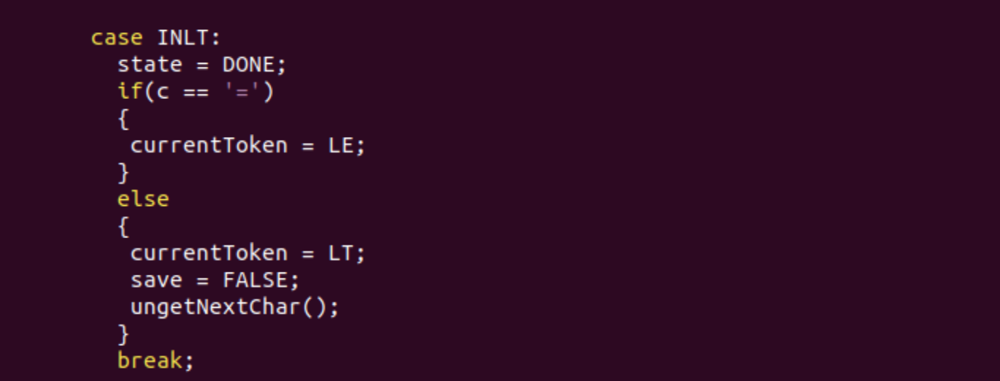

1. For Flex - Implementation

Copying **loucomp/lex/tiny.l** into **loucomp/cminus.l**, edited **cminus.l** file again.

Deleted

* tokens for tiny-compiler implementation
* existing print statement implemented in getToken()

Added

* reserved tokens (ex. “while”, “return”)
* single-character tokens (ex. ‘,’(COMMA) ‘]’(right bracket))
* double-character tokens (ex. “<=” (lesser than))
* comment-handling source for c-minus scanner implementation.

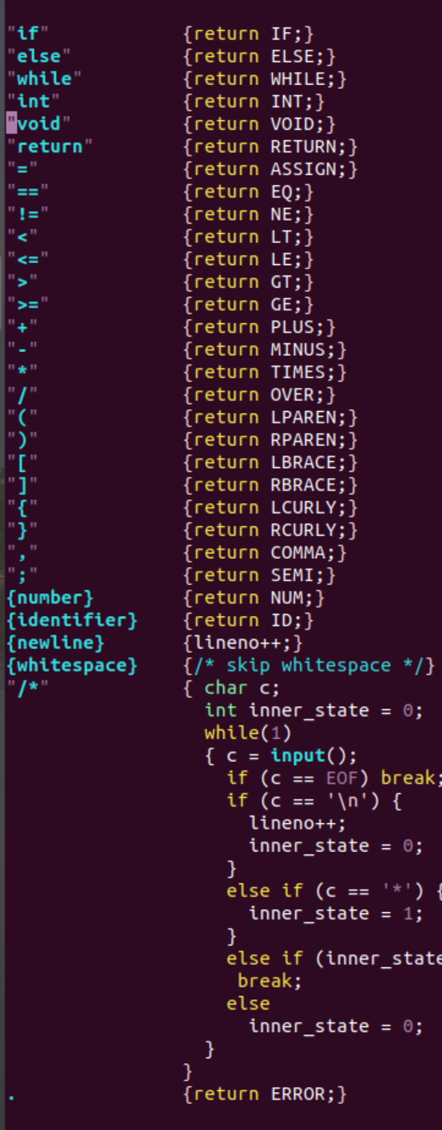

1. **How to Operate & Examples and Result Screenshots**

Given two examples ( test.1.txt & test.2.txt )

Simple “make clean” and “make” command would result in creating

1. /loucomp/scanner_flex
2. /loucomp/scanner_cimpl

By executing those with two examples, it resulted in four files,

* 1. flex_test_result_1.txt
  2. flex_test_result_2.txt
  3. cimpl_test_result_1.txt
  4. cimpl_test_result_2.txt

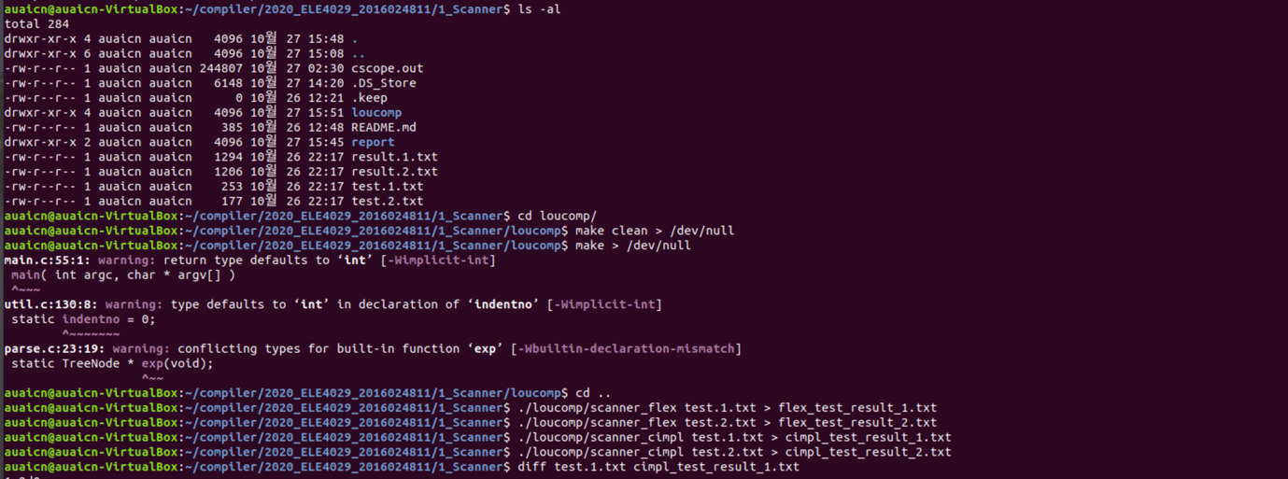

For C-implementation, Used linux command “diff [options] arguments” to achieve correctness.

